Katrina Burch
007012785
284-12 Photographic Preservation
Paper

Both archival institutions and armatures alike most likely will have dealt cellulose acetate negatives. While not as dangerous as cellulose nitrite, they still are dangerous to any collection. These negatives, when they deteriorate, produce acetic acid. This reaction’s main name is vinegar syndrome. This paper will discuss what happens to the negatives when they deteriorate, what to do when this deterioration starts, and finally, will look at prevention and care of the collections already affected, which as Bigourdan (n.d.) writes, “most acetate collections are affected by vinegar syndrome” (1).

The film that is today known as cellulose acetate is an acetate ester of cellulose fibers (Saracino, 2006, 6). These fibers are treated with acetic acid and made into film (Weaver, 2010, 10), first being created in 1865 (Saracino, 2006, 6). However, it did not begin to be used for photography until 1923 (Horvath, 1987, 6). While it has many other uses such as adhesives and synthetic fibers (Saracino, 2005, 6), its use in photography came about because the previous cellulose film, cellulose nitrite, is highly flammable (Saracino, 2006, 18) which made the cellulose acetate film safer and it became known as “safety-base” film (Keffe and Inch, 1984, 245). In 1937, cellulose acetate was replaced with cellulose diacetate, though cellulose acetate was still used (Bereijo, 2004, 324), as well as cellulose triacetate, which is mainly used for motion picture film (Lavédrine, 2003, 19). There are two distinct ways to tell whether or not a negative is made of cellulose acetate. The first the notch markings (if the negatives have them), the first notch will be a “u” shape (if the film is made before 1949) and the second way is that can read “safety film” on them (NPS, 1999).

As with most photographic processes, they, in the right conditions, will eventually begin to break down. One of the reasons that cellulose acetate was switched to over cellulose nitrite, besides it being flammable, was the fact that it was considered stable and supposedly free from degrading (Lobban, 1991, 51). “Observed as early as 1954” (Lavédrine, 2003, 19), cellulose acetate negatives began to break down. This deterioration of cellulose acetate negatives is known as “vinegar syndrome” (or as Lobban (1991) points out, it is also known as “dirty feet syndrome” (51)). Lobban (1991) gives us an official sounding definition when he writes that vinegar syndrome is “an acid-catalysed [sic] hydrolysis mechanism, with a slow incubation period leading to the rapid deterioration with the self-generated acid giving off the tell-tale vinegar smell” (51).

The chemistry of vinegar syndrome can be complicated. It is important to know, however, in order to help a collection. Cellulose acetate, when it is made, the base is made with plasticizers eventually that begin to degrade (Keffe and Inch, 1984). The breakdown of the plasticizers is due in part because cellulose acetate “is not very moisture resistant, and fluctuations in humidity could distort it” (Capell, 2010, 240). “Once the reaction begins, it can’t be stopped. In fact, it speeds itself up, growing faster and fasters” (Ram, 1992). This reaction is known as autocatalytic (Weaver, 2010, 10) due to the breakdown of the acetate produces acetic acid as mentioned. This in turn causes other cellulose acetate negatives to degrade, thus becoming a vicious cycle (Bereijo, 2004). This cycle is infectious (Bigourdan, n.d.) and thus if one infected negative occurs in a collection, the whole collection is infected.

When the negatives began to break down, the plasticizers that are changing they cause the base to shrink away from the emulsion (Keffe and Inch, 1984). This shrinking causes stress on the negative and it “causes the emulsion to separate from the acetate base, resulting in channeling” (Capell, 2010, 240) (See Appendix A for photograph). The degrading negative can also curl due to the shrinking (M., 2000, para. 4). When the negatives degrade, many also show bubbling. This is a result of the plasticizers evaporating (Capell, 2010). Another change that can be seen in negatives with vinegar syndrome is that there can be the colors. Colors such as blue or pink occur due to the antihalation dyes that were used in development (Capell, 2010). Lastly, Capell (2010) also makes note that many, though not all, negatives at the beginning of the deterioration process will give off a strong smell (of vinegar, hence the name) but little to no visible damage (239). In addition, Jacobsen (2000) stresses that “vinegar syndrome develops long before you smell it” (7). This smell of the negatives is probably the biggest indicator of a collection having vinegar syndrome but even if the smell of vinegar is not there it “does not mean the film in question has significantly deteriorated” (Ram, 1992). The reason the smell of a cellulose acetate collection is so important is that the human sense of smell is, according to Lavédrine (2003) “very sensitive to the smell of acetic acid” (19). Thus, the easiest way to tell if vinegar syndrome is happening to a collection is to open a container in the collection. If there is a smell of vinegar or acetic acid then the collection has active vinegar syndrome (M, 2000, para. 2). There are other ways to tell if a cellulose acetate collection is deteriorating. The best known practice is to use A-D strips (developed by the Image Permanence Institute) to test a collection (The Cutting Corporation, n.d.). These strips are used to test the acid amount by changing colors similar to an acidity pen. For cellulose acetate, or triacetate motion picture film, there are two companies out of Europe who make a button (Dancan in Denmark and BTT in Germany) that reacts “with the environment inside the can in such a way that when the air inside reaches a certain acidic level, they turn from green to yellow” (The Cutting Corporation, n.d. para. 3).

Because vinegar syndrome is contagious, it is important to deal with the problem as soon as possible. Once a collection is found to have negatives that have degraded, it is best, unless absolutely important to the institution that the negatives be discarded (Capell, 2010). Another way, is to remove the damaged negatives but keep them in cold storage and away from other photo collections (Horvath, 1987), Therefore, every item that is “showing the vinegar syndrome should be copied as soon as possible and destroyed” (Brems, 1991, 94).

The preservation of cellulose acetate negatives, especially those already damaged by vinegar syndrome, the best option may be digitization, though as Capell (2010) points out, it is not a universally accepted preservation strategy (236). However, there is a problem with digitization. Most institutions do not have the time, money, and/or, staff to handle large scale digitization projects (Capell, 2010). In order for digitization/duplication to be effective, it is important to prioritize the negatives so that those in worse decay should be duplicated/digitized first (Bigourdan, n.d.), but it is best to remember that “digital preservation requires a long-term financial and technological commitment” (Capell, 2010, 243).

While researching for this paper, another treatment/possible solution did appear. According to Capell (2010) it is possible to remove the emulsion layer from the base (241). This treatment involves “placing the negative into successive solvent baths to enable the emulsion separation to occur” (Hill, 2011, para. 5). Once the treatment is done, Hill (2011) suggests encapsulating it in Mylar and then scanning it (para. 8). However, it “is a risky treatment as a successful emulsion separation is not guaranteed” (Hill, 2011, para. 2). Along it with being risky, it is a last resort (Hill, 2011) as well as most institutions do not have a trained professional to accomplish this treatment (Capell, 2010).

Due to the fact that all things will eventually deteriorate, what are institutions to do to prevent and/or slow the spread of vinegar syndrome? Horvath (1987) explains that there are four ways that an institution can look into in order to slow and/or prevent the deterioration of cellulose acetate negatives. They are as follows and will be discussed in more detail in later paragraphs:
- Storage of nitrate negatives with acetate negatives
- Storage of acidic enclosure materials
- Temperature and humidity
- The environment around the acetate negatives (38)
The storing of cellulose acetate negatives is as important as the storing of prints are (Time-Life Books, 1982). The acetate negatives should be kept in paper enclosures are free from lignin, waxes, and plasticizers, as well as, are non-buffered (Keffe and Inch, 1984). These enclosures also must pass the PAT or Photographic Activity Test. This test follows the ISO18916 (IPI, 2011). Those that pass the PAT mean that the enclosures are “physically and chemically stable” (Weaver, 2010). Within the ISO standards, it says that among other things that the “pH is between 7.0 and 9.5” (Weaver, 2010, 5). For cellulose acetate, paper enclosures are the only way to store them as “plastics should not be used to store nitrate or older acetate film negatives as this may hasten their deterioration” (Weaver, 2010, 9). For newer acetate negatives, the plastic, while it is clear which gives the ability to see what the negative is, does not allow air circulation (Weaver, 2010, 7-8). This is fine, if the negative has not been exposed to vinegar syndrome. If it is, the lack of air circulation will keep the acetic acid in the plastic and cause further deterioration. Enclosures that cellulose acetate negatives should never be stored in are “Kraft paper, glassine, and highly acidic negative envelopes” as these “generally seem to accelerate the process of deterioration” (Horvath, 1987, 40). The enclosures that house the cellulose acetate are only “a secondary factor in controlling vinegar syndrome” (Bigourdan, n.d., 6). Lastly, when storing cellulose negatives, it is best to store them with themselves. This is for several reasons. One is that, if stored with other negatives such as cellulose nitrite, the deterioration of cellulose nitrite can push cellulose acetate negatives to start to decay as well.

One of the two most important ways to help prevent and/or minimize vinegar syndrome is temperature. “Acetate films have a life expectancy of about 50 years at moderate room temperatures” (Suffolk City Council, 2009, 8). In all actuality, cellulose acetate negatives should not be kept at room temperature (72F), if they are, they “should be rechecked at least every two to five years” (IPI, 2011) for signs of vinegar syndrome. Otherwise, if kept below room temperature, they only need to be “rechecked every five to ten years” (IPI, 2011). It is also recommended that the temperature not fluctuate more than five degrees in either direction IIFLAI, 1992, 3). Cycles of high temperature and high humidity are disastrous for cellulose acetate negatives.

One of the best ways to ensure that cellulose acetate negatives to do not have to encounter higher temperatures is to store them in cold storage. The Image Permanence Institute (2011) says that negatives kept in cold storage (41-50 F) need to be checked only 5-25 years. Those below 41F only need “checking every 25 years” (IPI, 2011). What happens when cellulose acetate negatives are stored in cold storage is that it “optimizes the chemical stability of photographic film, postpones further decay, and stabilizes film in critical condition” (Bigourdan, n.d., 2). Cold storage temperatures, according to Weaver (2010), the temperatures in cold storage range from -20 to -40 F (6). Thus, if there are negatives in a collection that is infected with vinegar syndrome already, taking the damaged negatives and putting them in cold storage slows down the process of decay and can be stored until a time where they can either be duplicated or digitized (Bigourdan, n.d.). There are many different options for cold storage based on the size of the facility, the size of the collection(s), and/or both. It is important to monitor the collections in the freezer and for any freezer that is used; it should be “frost-free” (Weaver, 2010, 8).

The other major factor in prevention of vinegar syndrome is humidity. Due to the way cellulose acetate negatives are made, they are highly susceptible to humidity absorption rates (Bereijo, 2004). The ideal Relative Humidity (RH) rate for cellulose acetate negatives is between 25 and 30% (Brems 1991). However, if there are other things in the collection such as slides, prints, and paper, the ideal RH is slightly higher (IFLAI, 1992). It is also important that there be no cycling of the humidity level if at all possible (IFLAI, 1992). The problems with controlling the humidity for photographs is that in many intuitions, there are other types of collections in and around cellulose acetate collections. These different types of materials such as paper need different levels of humidity so that they are not damaged as well.

Bigourdan (n.d.) writes that “acetate decay is a one-way street” (6). While this is true,
there are ways to preserve and protect the remaining parts of the collection as well as other collections in and around cellulose acetate negatives. Understanding the process of how vinegar syndrome occurs, what it looks like, how it can be prevented, and finally how to store cellulose acetate negatives. By understanding these things, it provides knowledge on how to keep items important to an institution safe from a potentially disaster. It is in most archival institutions best interest to know about vinegar syndrome.

Appendix A
Photos from The Hutchison Collection, Washington State University Manuscripts Archives Special Collections, Pullman, Washington.
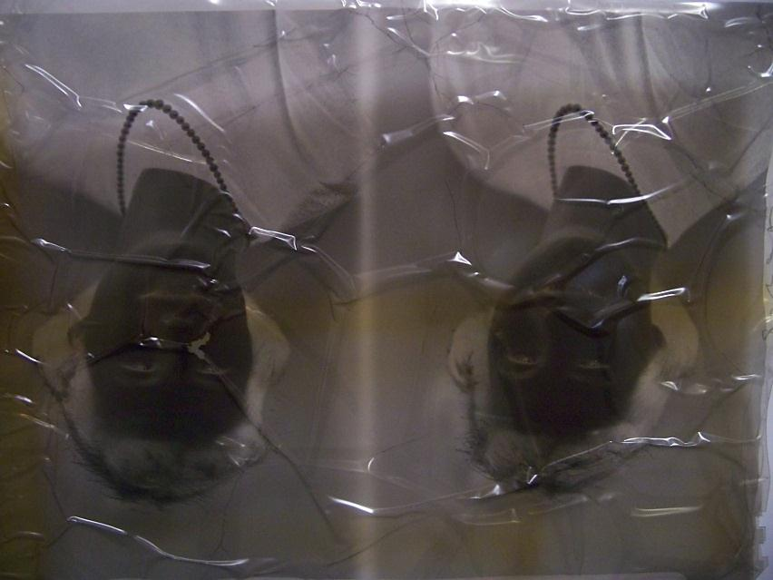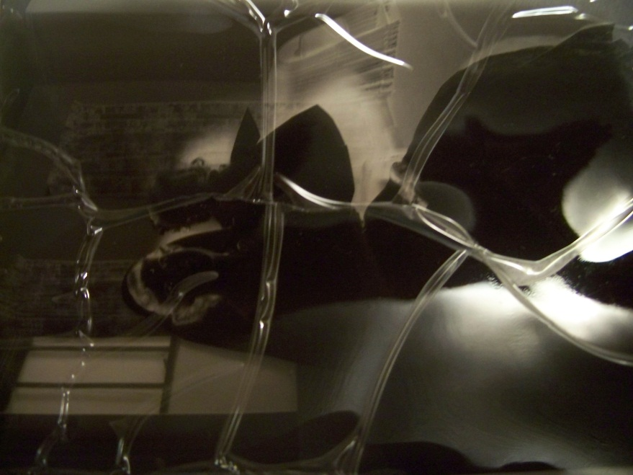

References
Bereijo, A. (2004). The conservation and preservation of film and magnetic materials (1): film materials.
In Library Review, 52(6), 323-331. Retrieved online from http://www.emeraldinsight.com.libaccess.sjlibrary.org/journals.htm?issn=0024 2535&volume=53&issue=6&articleid=859786&show=html&PHPSESSID=b6l90llj45hjcjcpdkt 5ppp2.
Bigourdan, J-L. (n.d.). Vinegar syndrome: an action plan. Image Permanence Institute. Retrieved online
from https://www.imagepermanenceinstitute.org/webfm_send/308.
Brems, K. (1991, March). Vinegar syndrome update. In Image Technology, 73(3), 94-96. Retrieved online http://libaccess.sjlibrary.org/login?url=http://search.ebscohost.com/login.aspx?direct=true&db
=f3h&AN=24243904&site=ehost-live
Capell, L. (2010). Digitization as a preservation method for damaged acetate negatives: a case study. In
The American Archivist, 73¸ 235-249. Retrieved online from
http://archivists.metapress.com.libaccess.sjlibrary.org/content/x381802g137421h3/fulltext.pdf.
Hill, R. (2011, July 29). Vinegar: the scent of self-destruction? [web log post]. Retrieved online from
http://www.vancouverarchives.ca/2011/07/vinegar-the-scent-of-self-destruction/#comment-
175.
Horvath, D., G. (1987). The acetate negative survey. The University of Louisville Photographic Archives: Louisville. Retrieved online from http://louisville.edu/library/ekstrom/special/AcetateNegativeSurvey.pdf.
Image Permanence Institute (2011). Acetate film base deterioration – the vinegar syndrome. [website].
Retrieved online from https://www.imagepermanenceinstitute.org/resources/newsletter-
archive/v12/vinegar-syndrome.
Image Permanence Institute (2011). Photographic Activity Test [website]. Retrieved online from
https://www.imagepermanenceinstitute.org/testing/pat.
International Federation of Library Associations and Institutions (IFLAI). (1992). Care, handling, and
storage of photographs. International Federation of Library Associations and Institutions Core Programme on Preservation and Conservation.
Jacobsen, M. (2000, May). Handling actively degrading film – tools and products. Image Technology,
82(4), 7-11. Retrieved online from
http://libaccess.sjlibrary.org/login?url=http://search.ebscohost.com/login.aspx?direct=true&db
=f3h&AN=22801701&site=ehost-live.
Keefe, L. E. jr. and Inch, D. (1984). The life of a photograph. Boston: Focal Press.
Lavédrine, B. (2003). A guide to the preventive conservation of photograph collections. Los
Angeles: The Getty Conservation Institute.

Lobban, G. (1991, February). Image preservation seminar. Image Technology, 73(2). 51-52. Retrieved
online from http://libaccess.sjlibrary.org/login?url=http://search.ebscohost.com/login.aspx?direct=true&db
=f3h&AN=24275363&site=ehost-live.
M. (2000, September 18). Acetic acid (vinegar syndrome) [web log post]. Retrieved online from
http://www.stilcasing.com/blog/?p=317.
National Park Service (NPS) (1999, November). Conserve o gram (14/9). Washington, D.C.: United States Printing Office. Retrieved online from http://www.nps.gov/museum/publications/conserveogram/14-09.pdf.
Ram, T. (1992, December 10). Molecular sieves and the prevention of the “vinegar syndrome”. Paper
presented at the 1992 AMIA conference. Retrieved online from
http://motion.kodak.com/US/en/motion/Support/Technical_Information/Storage/vinegar.htm
Saracino, K., H. (2006). Animation cel storage and preservation: caring for a unique American art form
[Master’s thesis]. John F. Kennedy University. Retrieved online from
http://library2.jfku.edu/Museum_Studies/Animation_Cel_Storage.pdf.
Suffolk City Council (2009). Caring for your archives (Information for searchers No. 6). Ipswich: Suffolk Record Office.
The Cutting Corporation (n.d.). Technical guides – vinegar syndrome. Retrieved online from
http://www.cuttingarchives.com/vinegar.htm.
Time-Life Books (eds). (1982). Caring for photographs: display, storage, restoration. Alexandria, VA:
Time-Life Books.
Weaver, G. (2010). Notes on Enclosures/PowerPoint slides. Week 8.
Weaver, G. (2010). Notes on deterioration of photographic materials. Week 7.
Weaver, G. (2010). Preservation Environment. Week 10 PowerPoint slides.

Bibliography
Cassagnac, J-P. (2002, April). Telegram from France. In Image Technology 84(3), 13-14. Retrieved online from http://libaccess.sjlibrary.org/login?url=http://search.ebscohost.com/login.aspx?direct=true&db=f h&AN=22842807&site=ehost-live.
Feller, R. L. (1994). Aspects of chemical research in conservation: the deterioration process. In Journal of the American Institute for Conservation of Historic and Artistic Works, 33, 91-94. Retrieved online from http://www.jstor.org.libaccess.sjlibrary.org/stable/3179419.
Ram, A.T. et all (1994). The effects and prevention of the vinegar syndrome. Journal if Imaging Science and Technology, 38(3), 249-261.
Image Permanence Institute (2001). A user’s guide for A-D strips: film base deterioration monitors. Retrieved online from http://www.wittnerkinotechnik.de/katalog/03_verbr/download/5174 en.pdf.
Woods, C. (1992, March 1). The treatment of cellulose diacetate negatives. In Journal of the Society of Archivists, 13(1), 46-48. Retrieved online from http://libaccess.sjlibrary.org/login?url=http://search.ebscohost.com/login.aspx?direct=true&db=a h&AN=9707183209&site=ehost-live.

