Step 2:
MARC is a cataloging standard that allows records to be put into a standard format. There are three main parts to MARC. One, how the record is structured. This structure is set in according to not only United States standards but international standards as well. Two, how the content within the record with be designated, and three, the content of the date within the records. A MARC record is structured into nine different fields. These fields are where the data for the record go. The rules used for MARC records are the AACR2r, which stands for Anglo-American Cataloging Rules second edition.
Step 3:
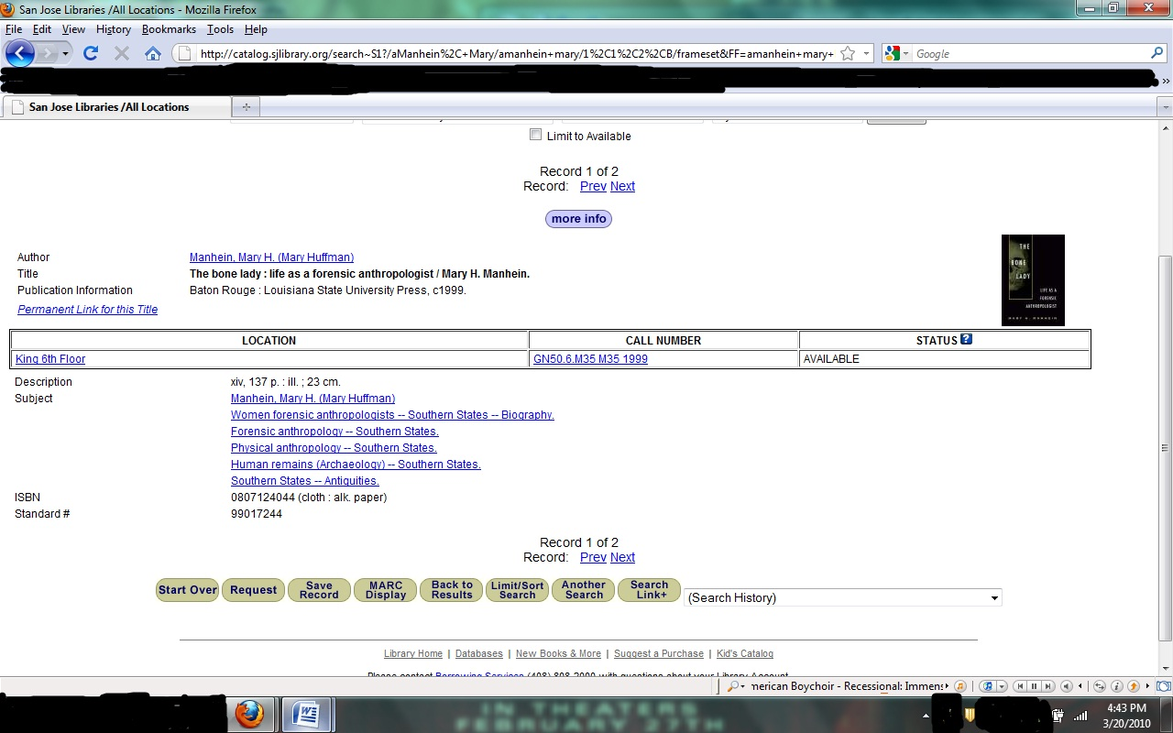
Step 5:
Copy cataloging is a process of taking records that have already been done for thousands of materials and using them in the library. These records (usually MARC) have been done by libraries all across the United States and Canada.
The main benefit of copy cataloging is that it is fast because most of the data and record have been filled in by somebody else. This cuts down on the amount that both the library has to store as well as completely fill out. “Copy cataloguing for most items is the answer to reducing the amount of cataloguing that must be done” (Mason, 2010). Related to this that if a library does create a new record then they can share that with other libraries and so it creates a big sharing network.
On the other hand, there are several drawbacks to using copy cataloging. One is that there are errors in the catalog copy as well as in MARC (though not as much). Things such as coding errors, spelling and grammar, bad call numbers, duplicate records, etc. Another problem relating to those are that someone would need to go through those records and clear out all the bad data. This, not only takes time but money.
Another major problem is that if a library does use both the records already made and makes their own, will there be a person double –checking the work done so that there are not any more new errors? This again will take time and money.

