For this project, I joined www.flickr.com and I will be giving a comparison look at that site and comparing it with my blog and its tagging system.
I added 21 pictures to my flickr.com page (they can be seen all together here: http://www.flickr.com/photos/48699450@N02/?saved=1). They are a collection of photos either I have taken myself, or my family has taken, or I have asked permission to use from the photographer. I uploaded the pictures using flickr’s upload option (See photo one as well as named Objects4-15). The process is easy to use and does not take a lot of time (unless you are uploading a lot of photos). I then went through and tagged them with key words and gave them titles (see picture 3, also labeled tagging 2-5). I chose to do keywords because it is the way flickr.com works best. Long sentences do not work as well in searching for pictures. So I used key words such as Horse, Ballroom, TV Shows, etc. At most, I used five words (Dancing With the Stars). The pictures that had keywords with more than one word, I put them in quotes for two reasons, one, this is what flickr says to do, and two, it keeps strings of key words together, so that when somebody searchers for say, San Francisco, they will not get pictures of other places with San in the name or pictures with names Francisco in the title.
In relation to the Mathes piece, I did not expect anything different as I have been using tags since 2005. Because of this expectation (or lack thereof), I decided for this project to compare the tagging system of flickr with that of my blog.
My blog (which in its entirety can be found here: http://wagrobanite.wordpress.com/) is hosted by a site called Wordpress.com. Wordpress is one of the largest blogging sites on the internet. The sign up is free (though there are more features if you pay, but in reality for most bloggers it is not worth it). To become a contributor, you have to sign up which is a painless process. You then have to name your blog (You can change it later!). For me this process went a lot faster as I was changing my blog over from another system (Google’s BlogSpot, at which I was not very happy with the features). Once your blog is created, all you have to do is start writing.
As with Flickr, tags are not required but for me as a blogger, I depend on them to find older posts and I, will be honest here, tend to have a higher opinion of a blog that does have tags. To me, it is about keeping up with the changing blogging atmosphere.
With my blog, the first thing I need to do is write a blog. Once the blog is done then I tag it (see picture 3). My tag structure within my blog is quite different than flickr. I name the event, then the event within the event (if there is one) and then which gender (if there is one). So for example for the 2010 Figure Skating World Championships it would look something like this: 2010 Worlds: Mens Free. My blog also allows me to choose from previously used tags as well as add tags to multiple posts at once (see pic 4). Another type of tagging feature that my blog had is I can add categories to each post.
The reason I like this system so that it allows me to find posts easier so that I want to find a post about Figure Skating, I can click on that category and then look through its tags.

1. 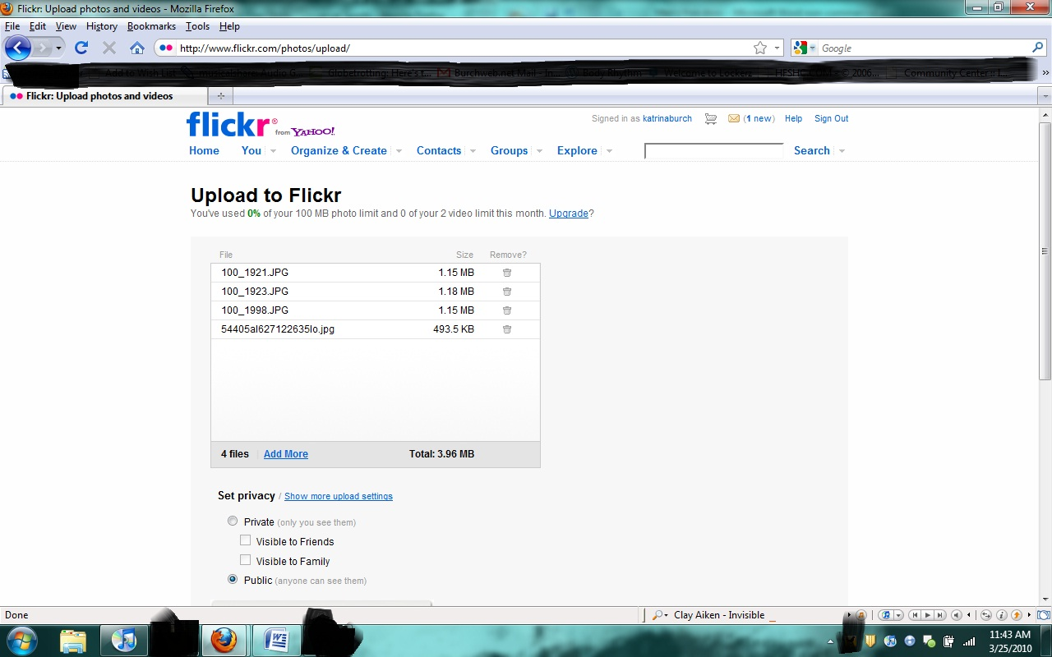
2. 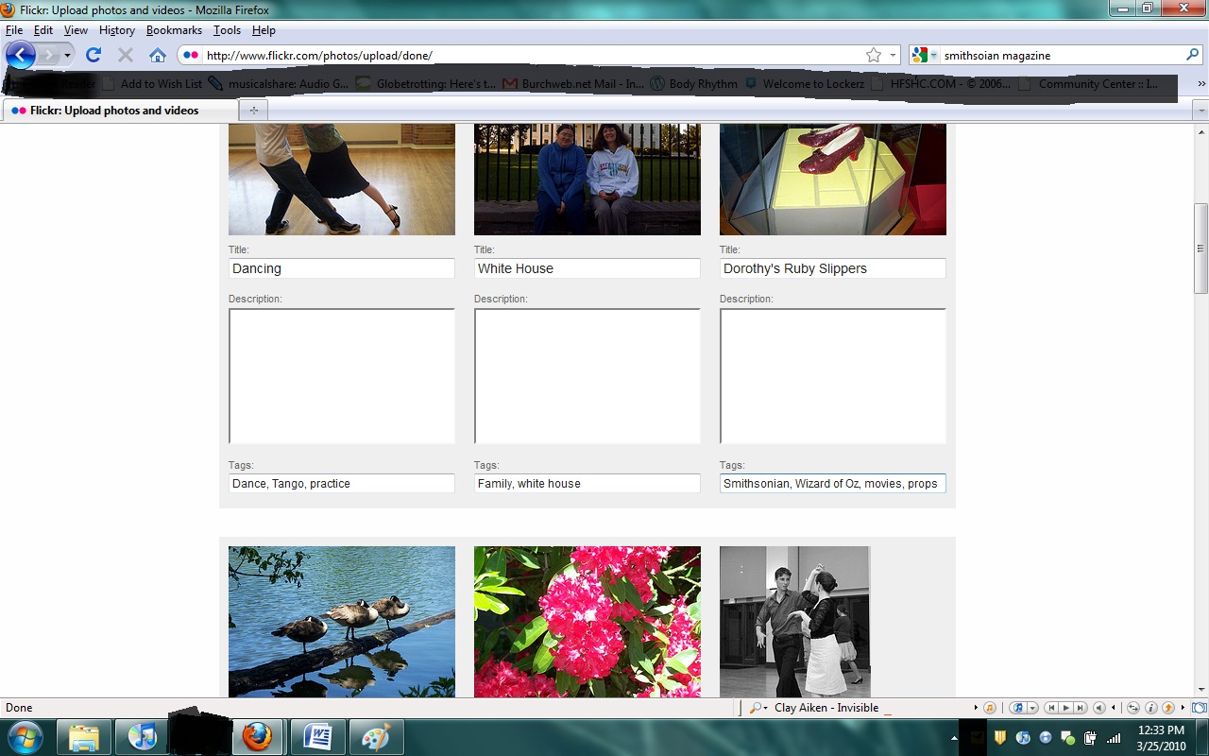
3. 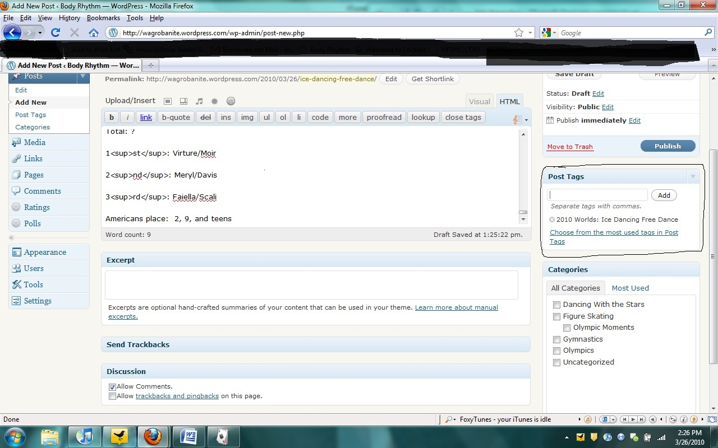
4. 